Project Report On
Music Management System
Using Link List

Submitted to
Dezyne École College
Towards the Partial Fulfilment of
BCA Semester 2nd
By
Meenakshi Mali


www.dezyneecole.com
2025-2026

Acknowledgement

We take this opportunity to express our sincere gratitude to Dezyne École College for providing us with the knowledge, resources, and guidance essential to the successful completion of this project.
Our deepest thanks to our respected Principal, Dr. Vinita Mathur, for her visionary leadership and continuous encouragement. Her commitment to academic excellence and student growth has been a constant source of motivation and pride.
We are equally thankful to all our faculty members for their consistent support, expert advice, and valuable insights that shaped our learning and helped us achieve this milestone.
Lastly, we extend heartfelt thanks to everyone who directly or indirectly contributed to the success of this project.
We are proud to be part of Dezyne École College, an institution that truly nurtures professionalism, innovation, and purpose.

With Sincere Appreciation,
Meenakshi Mali
Department Of BCA
Dezyne École College, Ajmer

Contents
Part 1: Introduction — What is a Linked List? 3
Singly vs Doubly — At a Glance 4
Why Not an Array? 4
Singly Linked List — All Operations 5
Node Structure & Memory Representation 5
Insert at Head — O(1) 6
Insert at Tail — O(1) with tail pointer 8
Insert at Position k — O(k) 9
Delete Operations — 3 Cases 11
Traversal — O(n) 15
Search by Keyword — O(n) 16
Count Nodes — O(1) Best Practice 17
Part 2: Doubly Linked List — Insertion, Deletion & Traversal 18
Insert at Tail — O(1) 21
Insert at Position k — O(k) 22
Delete Head — O(1) 24
Delete Tail — O(1) Key Advantage Over Singly 26
Delete given position Node — O(1) with pointer / O(n) if search required 27
Forward & Backward Traversal — O(n) each 29

Part 1: Introduction — What is a Linked List?
A Linked List is a linear data structure where elements (called nodes) are NOT stored in contiguous memory locations. Each node holds its data and one or two pointers — memory addresses — that link it to neighbouring nodes. The nodes can live anywhere in RAM; the pointers stitch them into a logical sequence.

Real world context of – MUSIC MANAGEMENT SYSTEM

Single Linklist Node Doubly Linklist Nodes
NULL
Next (address)
SONG DATA
Next (address)
NULL
NULL
SONG DATA
Next (address)

Each Node : data + 2 pointer ( prev + next )

Each can traverse BOTH directions

Head :- prev = NULL and Tail :- next = NULL
- Each Node :- DATA + 1 pointer (next)
- Can ONLY traversal forward
(head -> tail )
- Tail Node : next = null

music management system Songs in reverse-chronological order — newest at the top, oldest at the bottom. Three operations dominate this system:
- Insert at head: A new song always goes at the very top. This must be instant — O(1).
- Delete from any position: Content moderation removes any song immediately — O(1).
- Traverse from head to tail: Displaying the timeline scrolls from newest to oldest — O(n).
These three needs define the Linked List — a data structure that does all three efficiently.

Real-World Context — MUSIC MANAGEMENT SYETEM
Twitter's home timeline shows Songs in reverse-chronological order — newest at the top, oldest at the bottom. Three operations dominate this system:
- Insert at head: A new Song always goes at the very top. This must be instant — O(1).
- Delete from any position: Content moderation removes any Song immediately — O(1).
- Traverse from head to tail: Displaying the timeline scrolls from newest to oldest — O(n).
These three needs define the Linked List — a data structure that does all three efficiently.

Singly vs Doubly — At a Glance
Property | Singly Linked List | Doubly Linked List
Pointers per node | 1 (NEXT only) | 2 (PREV + NEXT)
Traversal direction | Forward only (head → tail) | Both directions
Delete tail | O(n) — must scan to 2nd-last | O(1) — use tail.prev
Delete any node (with ptr) | O(n) — scan for predecessor | O(1) — both neighbours known
Extra memory | Less (1 ptr × n) | More (2 ptr × n = +8 bytes/node)
Typical use | Stacks, hash chaining, simple queues | Timelines, browsers, LRU cache, deques

Why Not an Array?
Operation | Array | Linked List | Twitter's Need
Insert at front | O(n) — shift all elements right | O(1) — rewire 2 pointers | New Song on top — must be instant
Delete any element | O(n) — shift remaining elements | O(1) — rewire neighbours | Remove any Song instantly
Access by index | O(1) — direct formula | O(n) — traverse from head | Not needed for sequential display
Dynamic size (grow) | Needs reallocation | Trivial — just add a node | Song count is unpredictable
Search | O(n) linear, O(log n) binary | O(n) linear only | Both require traversal for unsorted data

Singly Linked List — All Operations

Node Structure & Memory Representation
In a singly linked list each node stores data and ONE pointer — next — which holds the memory address of the following node. The last node's next = NULL. We maintain a head pointer to always find the start, and optionally a tail pointer for efficient end-access.

C++ struct:

Memory layout example:
public:
string SID;
string ANAME;
string SD;
NODE *NEXT;
NODE(string x, string y, string z)
{
SID = x;
ANAME = y;
SD = z;
NEXT = nullptr;
}
};
class LinkList
{
public:
string SID;
int SCNT;
string AName, SCAP;
NODE *START,*END;
int countNode;
LinkList(){
SCNT = 1001;
countNode = 0;
START = nullptr;
END = nullptr;
}

Insert at Head — O(1)
Singly linked list – Insert at Head & Insert at Tail
INSERT AT HEAD
BEFORE :-

- New node = new node (song A)

- Newnode.next = head ( = song B)
- Head = newNode
AFTER :-i

NULL
SONG C
SONG B

SONG A
SONG B
SONG C
NULL

INSERT AT TAIL – 0(1) WITH TAIL PAIR
BEFORE :-

New node = new node (song C)

tail.next = head ( = song B)

tail = newNode
AFTER :-
SONG B
SONG C
NULL

SONG B
NULL
SONG C
SONG A

INSERT AT GIVEN POSITION
BEFORE :-

Curr = head :- travers 1 stepp to reach pos 1 ( SONG B )

NewNode.next = cur.next ( = SONG C at pos 2 )

Curr,next = newNode

SONG B
Pos 1
NULL
SONG C
Pos 2

SONG A
Pos 0

Concept
The newest Song always goes at the top of the timeline. Head insertion achieves this in exactly 2 pointer operations — always O(1) regardless of how many Songs already exist

Step-by-Step Algorithm
- Create new node: SongNode* newNode = new SongNode(text, user); — allocates heap memory, sets next = NULL.
- Connect forward: newNode->next = head; — new node now points to the current head (will become 2nd node).
- Move head pointer: head = newNode; — head now refers to the new node.
- Handle empty list: If the list was empty, also set tail = newNode;
- Increment counter: size++;

code
int insertNode(int opr)
{
system("cls");
if ( opr == 1){
cout<<"\n\nInsert SONG At Beginning . \n\n";
getData();
NODE *TEMP = new NODE(SID,AName, SCAP);
if ( TEMP == nullptr){
cout<<"Insufficient Memory.. \n";
return 0;
}
if ( START == nullptr){
END = START = TEMP;
}
else{
TEMP->NEXT = START;
START = TEMP;
}
countNode++;
SCNT++;
}

Insert at Tail — O(1) with tail pointer
Without tail pointer: Must traverse all n nodes to reach the last one, then append. Cost = O(n).
With tail pointer (always recommended): Directly access tail, attach new node, advance tail. Cost = O(1).

Step-by-Step Algorithm (with tail pointer)
- Create new node SongNode* newNode = new SongNode(text, user); — newNode->next = NULL.
- Handle empty list: If head == NULL: head = tail = newNode; return.
- Connect: tail->next = newNode; — current tail now points to the new node.
- Advance tail: tail = newNode; — tail pointer moves to the new last node.
- Increment counter: size++;

Code
else if ( opr == 2){
cout<<"\n\nInsert SONG At End . \n\n";
getData();
NODE *TEMP = new NODE(SID,AName, SCAP);

if ( TEMP == nullptr){
cout<<"Insufficient Memory.. \n";
return 0;
}
if ( START == nullptr){
END = START = TEMP;
}
else{
END->NEXT = TEMP;
END = TEMP;
}
countNode++;
SCNT++;
}

Insert at Position k — O(k)
Three sub-cases
- k = 0: Same as insertAtHead() — O(1).
- k = size (last position + 1): Same as insertAtTail() — O(1).
- 0 < k < size (middle): Traverse k-1 steps to find the predecessor node, then rewire 2 pointers.

Step-by-Step Algorithm for Middle Insert
- Create newNode.
- Start curr = head; traverse k-1 steps: for(int i=0; i<k-1; i++) curr = curr->next;
- newNode->next = curr->next; — new node points to what curr was pointing to.
- curr->next = newNode; — curr now points to new node.
- size++;

code
else if ( opr == 3){
cout<<"\n\nInsert SONG At Given Position . \n\n";
cout<<"Total Songs -- "<<countNode<<"\n\n";
int pos;
getData();
cout<<"Enter Position Between 0 to "<<countNode<<" -- ";
cin>>pos;

NODE *TEMP = new NODE(SID,AName, SCAP);
if ( TEMP == nullptr){
cout<<"Insufficient Memory.. \n";
return 0;
}
int i;
NODE *TEMP1 = START;
for ( i = 2 ; i < pos ; i++){
TEMP1 = TEMP1->NEXT;
}
if ( START == nullptr){
END = START = TEMP;
}
else{
TEMP->NEXT = TEMP1->NEXT;
TEMP1->NEXT = TEMP;
if ( TEMP1 == END){
END = TEMP1->NEXT;
}
}
countNode++;
SCNT++;
}

Delete Operations — 3 Cases
INSERT AT GIVEN POSITION

Before case Delete

After Case Delete

Case3:- delete middle by value
- Prev = NULL, curr = head
- While curr.data != target : prev= curr, curr= curr.next
- Prev.next = curr.next
- Delete curr
Case 2 :- delete tail – 0(n)
- 1.Curr = head
- Traverse until curr.next -== tail
- Curr.next = NULL
- Tail = curr.delete old_tail
Case 1: Delete HEAD -0(1)

- 1.temp = head
- 2. head = hrad.next
- 3. delete temp
- 4. if head == null: tail == null

SONG A
SONG B
NULL
SONG C

SONG A
SONG C
NULL
SONG B

SONG C
NULL
SONG B

Case 1 — Delete Head — O(1)
- Moving the head pointer one step forward effectively removes the first node. No traversal needed.
- temp = head; — save the node to free later.
- head = head->next; — head now points to the 2nd node (new head).
- If head != NULL: it was a single-node list: set tail = NULL;
- delete temp; — free heap memory.
- size--;

int deleteNode(int opr)
{
NODE *TEMP;
if ( opr == 1){
cout<<"\n\nDelete SONG From Beginning . \n\n";
if ( START == nullptr)
{
cout<<"PlayList is Empty.. \n\n";
return 0;
}
else if ( START->NEXT == nullptr){
TEMP = START;
END = START = nullptr;
}
else{
TEMP = START;
START = START->NEXT;
}
countNode--;
delete(TEMP);
cout<<"\nSONG Deleted Successfully\n\n";
}

Case 2 — Delete Tail — O(n) ← Singly's Weakness
Problem: To delete the tail we must update the second-to-last node's next pointer to NULL. In a singly linked list the only way to find that node is to traverse from head — O(n). This is why doubly linked lists are preferred when tail deletion is frequent.
- Start curr = head; traverse until curr->next == tail;
- curr->next = NULL; — second-to-last now terminates the list.
- delete tail; then tail = curr;
- size--;
else if ( opr == 2){
cout<<"\n\nDelete SONG From End . \n\n";
if ( START == nullptr)
{
cout<<"PlayList is Empty.. \n\n";
return 0;
}
else if ( START->NEXT == nullptr){
TEMP = START;
END = START = nullptr;
}
else{
TEMP = START;
int c = 1;
while ( TEMP->NEXT != END)
{
cout<<c++<<endl;
TEMP = TEMP->NEXT;
}
NODE *T1 = END;
TEMP->NEXT = nullptr;
END = TEMP;
cout<<END->ANAME<<endl;
delete(T1);
}
countNode--;
cout<<"\nSONG Deleted Successfully\n\n";
}
Case 3 — Delete Middle Node by Given Position — O(n)
- Find the target node and its predecessor simultaneously using two pointers, then bypass the target.
- prev = NULL; curr = head;
- Traverse: while curr != NULL and curr->data != target: prev = curr; curr = curr->next;
- If curr == NULL: value not found — return.
- prev->next = curr->next; — predecessor skips over the target node.
- If curr == tail: tail = prev; — update tail pointer.
- delete curr; size--;

else if ( opr == 3){
cout<<"\n\nDelete SONG From Given Position . \n\n";

if ( START == nullptr)
{
cout<<"PlayList is Empty.. \n\n";
return 0;
}
int pos;
cout<<"Enter Position for Delete (1 - "<<countNode<<") - ";
cin>>pos;
if ( pos == 1 && START == END)
{
TEMP = START;
START = END = nullptr;
}
else{
TEMP = START;
for (int i = 2 ; i < pos ; i++)
{
TEMP = TEMP->NEXT;
}
if (TEMP->NEXT == END){
NODE *T1 = END;
TEMP->NEXT = nullptr;
END = TEMP;
}
else{
NODE *T1 = TEMP->NEXT;
TEMP->NEXT = T1->NEXT;
delete(T1);
}
}
countNode--;
cout<<"\nSONG Deleted Successfully\n\n";
}

Traversal — O(n)
Singly Linked List – Traversal , search , count & Reverse

Search – o(n) always

Curr = head.scanned = 0

While curr != NULL;

Scanned ++

If curr.data has keyword

Return curr <- FOUND

Curr = curr.next

Return NULL <- NOT FOUND

Traversal – o(n)

- Start curr = head

- Loop : while curr! = null
  - Print curr.data
  - Curr = curr.next

- End :- print ‘NULL’

- Output s4 – s3 – s2 – s1 - NULL

Reverse – o(n) , o(1) space

Prev = NULL

While curr != NULL

Curr = curr.next <- save

Curr.next = prev <- filp

Prev = curr
COUNT – 0(1) best practice

Count = 0 : curr = head

While curr= NULL: count++

Method 2(maintain counter)

Class has iont size = 0

Insert node(): sze++

deleteNode () size --

SONG A
NULL
SONG B
SONG C

Concept
Traversal visits every node exactly once, following next pointers from head until NULL. This is how SONG renders your MANAGEMENT from top to bottom — each Song displayed in order.
- curr = head; — start at newest Song.
- Loop: while (curr != nullptr) — stop when we fall off the end.
- Inside loop: process curr->data; then curr = curr->next;

void showNode()
{
cout<<"\n\nSONG Detail -- \n\n";
cout<<"* Head -> ";
NODE *TEMP = START;
if ( START == nullptr){
cout<<"null \n\nSONG Detail is empty\n";
}
else{
while ( TEMP!= nullptr){
cout<<"["<<TEMP->SID<<", ";
cout<<TEMP->ANAME<<", ";
cout<<TEMP->SD<<"] -> ";
TEMP = TEMP->NEXT;
}
cout<<"Null";
}
}

Search by Keyword — O(n)
Why O(n) only: Linked lists have no index formula. To find a node you must start at head and examine each node one by one. Best case O(1) if found at head. Worst case O(n) if at tail or absent.
Why binary search is impossible: Binary search requires jumping to the middle element. In a linked list, reaching node i requires following i pointers from head — O(i). So finding the middle costs O(n/2), making binary search O(n log n) — worse than linear O(n).
int searchTweetInNode()
{
cout<<"\n\nSearch SONG in PlayList -- \n\n";
cout<<"* Head -> ";
NODE *TEMP = START;
if ( START == nullptr){
cout<<"null \n\ Playlist is empty\n";
return 0;
}
else{
cout<<"\n\nEnter ARTIST Name To Find DETAIL -- ";
string Aname;
int counter = 0;
getline(cin,Aname);
while ( TEMP!= nullptr){
if (TEMP->ANAME == Aname)
{
cout<<"\n["<<TEMP->SID<<", ";
cout<<TEMP->ANAME<<", ";
cout<<TEMP->SD<<"]\n";
counter++;
}
TEMP = TEMP->NEXT;
}
if ( counter == 0){
cout<<"\nNo SONG Found..\n\n";
}
}

Count Nodes — O(1) Best Practice
Approach | Algorithm | Time | Recommendation
Traverse and count | curr=head; while curr≠NULL: count++; curr=curr.next | O(n) per call | Avoid for frequent calls
Maintain size counter | size++ on insert, size-- on delete, getCount() returns size | O(1) per call | Always use this approach

void countNodes()
{
system("cls");
cout<<"Count SONG Module --\n\n";
cout<<"Total Number of SONG -- "<<countNode<<" SONG Available\n\n";
}

Part 2: Doubly Linked List — Insertion, Deletion & Traversal

What the prev Pointer Adds
A doubly linked list adds one extra pointer — prev — to every node. This single addition costs 8 bytes per node on a 64-bit system but unlocks three major advantages:
- O(1) delete of any node — both neighbours are immediately accessible via prev and next. No scanning needed.
- O(1) tail deletion — tail.prev gives the second-to-last node directly. No traversal.
- Backward traversal — start at tail, follow prev pointers. Impossible in singly linked lists.

C++ Node Structure for Doubly Linked List

class NODED
{
public:
NODED *PREV;
string ID;
string ANAME;
string SONG;
NODED *NEXT;
NODED(string x, string y, string z)
{
PREV = nullptr;
ID = x;
ANAME = y;
SONG = z;
NEXT = nullptr;
}
};
class DLinkList
{
public:
string SID;
int SCNT;
string ANAME, USONG;
NODED *START,*END;
int countNode;
DLinkList(){
SCNT = 1001;
countNode = 0;
START = nullptr;
END = nullptr;
}
void getData()
{
SID = "SONG"+ to_string(SCNT);
cout<<"\nEnter SID -- "<<SID<<endl;
//getline(cin,SID);
cout<<"Enter ARTIST Name -- ";
//cin.ignore();
getline(cin,ANAME);
cout<<"Enter SONG -- ";
getline(cin,USONG);
}

INSERT AT HEAD
BEFORE :-

AFTER :-

Next (address)
NULL
SONG B
SONG C
Prev
NULL

SONG A
NULL
Next (address)
NULL
SONG B
Next (address)
NULL
SONG C
Next (address)

Steps :-
1 . create newNode
2. newNode.next = head(B)
3 . head. Prev = newNode <- key
4. head = newNode

INSERT AT END
BEFORE :-

AFTER :-

NULL
SONG A
Next (address)
Prev
SONG B
NULL

SONG A
Next (address)
NULL
Prev
SONG B
NULL
Next (address)
prev
SONG C

Step :-
- Create newNode
- newNode prev = tail(B) <- key !
- tail.next = newNode
- tail = newNode
INSERT AT GIVEN POSITION

BEFORE :-

AFTER :-

NULL
Next (address)
SONG B
NULL
Prev
NULL
SONG A

NULL
prev
SONG C
Next (address)
Next (address)
Prev
SONG B
SONG A

step
- newNode.prev = A
- newNode.next = B
- A.next = newNode
- B.prev = newNode <- doubly needs this extra step

Extra Step vs Singly
Compared to singly insertion at head, doubly adds one step: setting the old head's prev pointer back to the new node.

Algorithm — 4 pointer operations
- Create: SongNodeDL* newNode = new SongNodeDL(text, user); — prev=NULL, next=NULL.
- If empty: head = tail = newNode; return.
- Connect forward: newNode->next = head; — new node points to old head.
- Connect backward: head->prev = newNode; — old head points BACK to new node. ← extra step vs singly!
- Advance head: head = newNode;
- size++;

int insertNode(int opr)
{
system("cls");
if ( opr == 1){
cout<<"\n\nInsert SONG At Beginning . \n\n";
getData();
NODED *TEMP = new NODED(SID,ANAME, USONG);
if ( TEMP == nullptr){
cout<<"Insufficient Memory.. \n";
return 0;
}
if ( START == nullptr){
END = START = TEMP;
}
else{
TEMP->NEXT = START;
START->PREV = TEMP;
START = TEMP;
}
cout<<END->ANAME;
countNode++;
SCNT++;
}

Insert at Tail — O(1)
Always O(1): Doubly linked lists always maintain a tail pointer. Appending is direct — no traversal required in either the empty or non-empty case.

Algorithm — 4 pointer operations
- Create: SongNodeDL* newNode = new SongNodeDL(text, user);
- If empty: head = tail = newNode; return.
- Connect backward: newNode->prev = tail; — new node looks BACK at current tail.
- Connect forward: tail->next = newNode; — current tail points forward to new node.
- Advance tail: tail = newNode;
- size++;

else if ( opr == 2){
cout<<"\n\nInsert END At End . \n\n";
getData();
NODED *TEMP = new NODED(SID,ANAME, USONG);
if ( TEMP == nullptr){
cout<<"Insufficient Memory.. \n";
return 0;
}
if ( START == nullptr){
END = START = TEMP;
}
else{
END->NEXT = TEMP;
TEMP->PREV = END;
END = TEMP;
}
countNode++;
SCNT++;
}

Insert at Position k — O(k)
Middle case — 4 pointer rewires (vs 2 in singly)
Traverse to position k-1 (same as singly), but now must wire FOUR pointers: both neighbours' prev and next must be updated.

else if ( opr == 3){
cout<<"\n\nInsert SONG At Given Position . \n\n";
cout<<"Total Nodes -- "<<countNode<<"\n\n";
int pos;
getData();
cout<<"Enter SONG Position Between 0 to "<<countNode<<" -- ";
cin>>pos;

NODED *TEMP = new NODED(SID,ANAME, USONG);
if ( TEMP == nullptr){
cout<<"Insufficient Memory.. \n";
return 0;
}
int i;
NODED *TEMP1 = START;
for ( i = 2 ; i < pos ; i++){
TEMP1 = TEMP1->NEXT;
}
if ( START == nullptr){
END = START = TEMP;
}
else{

TEMP->NEXT = TEMP1->NEXT;
TEMP1->NEXT = TEMP;
TEMP->PREV = TEMP1;
TEMP->NEXT->PREV=TEMP;
if ( TEMP1 == END){
END = TEMP1->NEXT;
}
}
countNode++;
SCNT++;
}

Delete Head — O(1)
DELETE AT HEAD
NULL
SONG B
DELETE HEAD – 0(1)

- Head = head.next
- Head.prev = NULL <- new head has no pred
- Delete old_head
- If head == NULL tail = NULL

BEFORE :-

AFTER :-

Prev
SONG A
Next (address)
Next (address)
SONG B
NULL
NULL
SONG C
Prev

SONG C
NULL
Prev
Next (address)

DELETE AT TAIL
NULL
SONG A
Next (address)
SONG B
Prev
DELETE TAIL – 0(1)

Tail = tail.prev <- via prev pointer

Tail.next = NULL

Delete old_tail

If tail == NULL ,head = NULL

BEFORE :-

AFTER :-

NULL
SONG B
NULL
Next (address)
SONG A
Prev
Next (address)
prev
NULL
SONG C

DELETE AT GIVEN POSITION
SONG B
NULL
DELETE AT POSITION– 0(1)

N.prev.next = n.next(A skip over N)

N.netx.prev = N.prev (B pointer back to A )

Delete N

BEFORE :-

AFTER :-

SONG B
Next (address)
prev
SONG C
NULL
Prev
SONG A
Next (address)
NULL

Prev
NULL
SONG C
NULL
Next (address)
SONG A

Algorithm
- Check: If head == NULL: empty list, return.
- Save: SongNodeDL* temp = head;
- Advance head: head = head->next;
- If head != NULL: head->prev = nullptr; — new head has no predecessor.
- Else (list now empty): tail = nullptr;
- Free: delete temp; size--;

Delete node at head
int deleteNode(int opr)
{
NODED *TEMP;
if ( opr == 1){
cout<<"\n\nDelete SONG From Beginning . \n\n";
if ( START == nullptr)
{
cout<<"Playlist is Empty.. \n\n";
return 0;
}
else if ( START->NEXT == nullptr){
TEMP = START;
END = START = nullptr;
}
else{
TEMP = START;
START = START->NEXT;
START->PREV=nullptr;
}
countNode--;
delete(TEMP);
cout<<"\n SONG Node Deleted Successfully\n\n";
}

Delete Tail — O(1) ★ Key Advantage Over Singly
Why This is Doubly's Key Advantage
In a singly linked list, deleting the tail requires O(n) traversal to find the second-to-last node (which must have its next set to NULL). In a doubly linked list, tail.prev ALREADY points to the second-to-last node — O(1), no scanning!

Algorithm — 3 pointer operations
- Check: If tail == NULL: empty list, return.
- Save: SongNodeDL* temp = tail;
- Advance tail BACKWARD: tail = tail->prev; ← ONLY possible because of the prev pointer!
- If tail != NULL: tail->next = nullptr; — new tail has no successor.
- Else (list now empty): head = nullptr;
- delete temp; size--;

cout<<"\n\nDelete SONG From End . \n\n";
if ( START == nullptr)
{
cout<<"Playlist is Empty.. \n\n";
return 0;
}
else if ( START->NEXT == nullptr){
TEMP = START;
END = START = nullptr;
}
else{
NODED *TEMP = END;
END = END->PREV;
END->NEXT = nullptr;
delete(TEMP);
}
countNode--;
cout<<"\n SONG Node Deleted Successfully\n\n";
}

Delete given position Node — O(1) with pointer / O(n) if search required
The Biggest Advantage
If you already have a direct pointer to the node to delete, O(1) is achievable because both neighbours are accessible via prev and next. Just 2 rewires bypass the node completely.

Algorithm — 2 pointer rewires
- Check edge cases: if N == head → call deleteHead(); if N == tail → call deleteTail().
- A.next = N.next: N->prev->next = N->next; — predecessor skips over N.
- B.prev = N.prev: N->next->prev = N->prev; — successor points back past N.
- delete N; size--;
else if ( opr == 3){
cout<<"\n\nDelete SONG From Given Position . \n\n";

if ( START == nullptr)
{
cout<<"Playlist is Empty.. \n\n";
return 0;
}
int pos;
cout<<"Enter Position for Delete (1 - "<<countNode<<") - ";
cin>>pos;
if ( pos == 1 && START == END)
{
TEMP = START;
START = END = nullptr;
}
else{
TEMP = START;
for (int i = 1 ; i < pos ; i++)
{
TEMP = TEMP->NEXT;
}
if (TEMP == END){
TEMP->PREV->NEXT = nullptr;
END = TEMP->PREV;
delete(TEMP);
}
else{
TEMP->PREV->NEXT = TEMP->NEXT;
TEMP->NEXT->PREV = TEMP->PREV;
delete(TEMP);
}
}
countNode--;
cout<<"\n SONG Node Deleted Successfully\n\n";
}

Forward & Backward Traversal — O(n) each
Doubbly LinkList Forward And Backward Traversal

Next (address)
Prev
prev
SONG C
NULL
Next (address)
SONG A
SONG B
NULL

BACKWORD TRAVERSAL
Step 1: Start
Step 2: Set PTR = TAIL
Step 3: If TAIL = NULL
Print "List is Empty"
Go to Step 7
Step 4: Repeat while PTR ≠ NULL
Print PTR->DATA
PTR = PTR->PREV
Step 5: End Repeat
Step 6: Stop Traversal
Step 7: End
FORWARD TRAVERSAL
Step 1: Start
Step 2: Set PTR = HEAD
Step 3: If HEAD = NULL
Print "List is Empty"
Go to Step 7
Step 4: Repeat while PTR ≠ NULL
Print PTR->DATA
PTR = PTR->NEXT
Step 5: End Repeat
Step 6: Stop Traversal
Step 7: End

Forward Traversal (Newest → Oldest)
int showNode()
{
cout<<"\n\nDoubly Link List Traversal Of SONGS -- \n\n";
cout<<"* Head -> ";
if ( START == nullptr){
cout<<"null \n\nlist is empty\n";
return 0;
}
cout<<"\n\n1. Forward SONG Traversal..\n";
cout<<"2. Backward SONG Traversal\n";
cout<<"3. Goto to Main Menu..\n";
cout<<"4. Exit\n";
char c = getch();
if ( c == '1'){
cout<<"\n\nForward Traversal\n\n";
cout<<"null <- ";
NODED *TEMP = START;
while ( TEMP!= nullptr){
cout<<"["<<TEMP->ID<<", ";
cout<<TEMP->ANAME<<", ";
cout<<TEMP->SONG<<"] -> ";
TEMP = TEMP->NEXT;
}
cout<<"Null\n\n";
}

Backward Traversal (Oldest → Newest) ← Impossible in Singly
Unique to doubly linked lists. Start at tail, follow prev pointers. This direction is physically impossible in a singly linked list because there is no prev pointer.

else if ( c == '2'){
cout<<"\n\nBackward SONG Traversal\n\n";
cout<<"null <- ";
NODED *TEMP = END;
while ( TEMP!= nullptr){
cout<<"["<<TEMP->ID<<", ";
cout<<TEMP->ANAME<<", ";
cout<<TEMP->SONG<<"] -> ";
TEMP = TEMP->PREV;
}
cout<<"Null\n\n";
}
else if ( c == '3'){
MainMenu();
}
else if (c == '4'){
exit(0);
}

}

Real-World Applications of Backward Traversal
Application | How Backward Traversal is Used
Browser back button | Navigate history in reverse (most recent → oldest visited)
Text editor undo/redo | Move backward through change history to undo actions
Music player Previous Track | Go backward through the playlist
LRU Cache eviction | Tail is LRU item — accessed via backward from end, evicted O(1)
Twitter / Social Media | Show thread in chronological order (oldest reply first)

This code is the main module of a C++ based Music Management System Project
that uses both Singly Linked List and Doubly Linked List concepts.
It acts like the starting menu (main controller) of the whole project.

CODE OF MAIN MODULE

#include<iostream>
#include<conio.h>
#include"singlylinklist.cpp"
#include"dubblylinklist.cpp"
class MainLinkList
{
public:
LinkList l;
DLinkList dl;
void MainLinkListModule()
{
system("cls");
cout<<"------ WELCOME MUSIC SYSTEM PROJECT ------\n\n";
cout<<"1. Singly Link List \n\n";
cout<<"2. Doubly Link List \n\n";
cout<<"3. Exit \n\n";
cout<<"Choose any one of them....";
char c = getch();
if ( c == '1'){
l.MainMenu();
}
else if ( c == '2'){
dl.MainMenu();
}
else if ( c == '3'){
exit(0);
}
}
};
int main()
{
MainLinkList mll;
mll.MainLinkListModule();
cout<<"\n\nThank You for Using My App..\m\m";
cout<<"Design & Coded By – Meenakshi Mali .. \n\n";
}

Output
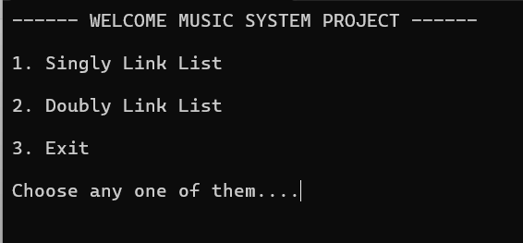

Final code SinglyLinkList

#include<iostream>
#include<conio.h>
#include<string>
using namespace std;
class NODE
{
public:
string SID;
string ANAME;
string SD;
NODE *NEXT;
NODE(string x, string y, string z)
{
SID = x;
ANAME = y;
SD = z;
NEXT = nullptr;
}
};
class LinkList
{
public:
string SID;
int SCNT;
string AName, SCAP;
NODE *START,*END;
int countNode;
LinkList(){
SCNT = 1001;
countNode = 0;
START = nullptr;
END = nullptr;
}
void getData()
{
SID = "SONG"+ to_string(SCNT);
cout<<"\GENERATE SONG ID -- "<<SID<<endl;
cout<<"Enter ARTIST NAME -- ";
getline(cin,AName);
cout<<"Enter SONG Name -- ";
getline(cin,SCAP);
}
char continueCheck()
{
char c;
cout<<"\n\nAre you.. \n";
cout<<"1. Continue with Same\n";
cout<<"2. Go to Main Previous Menu\n";
cout<<"3. Go to Main Menu..\n";
cout<<"4. Exit\n";
c = getch();
if ( c == '4'){
thanksLine();
exit(0);
}else{
return (c);
}
}
int insertNode(int opr)
{
system("cls");
if ( opr == 1){
cout<<"\n\nInsert SONG At Beginning . \n\n";
getData();
NODE *TEMP = new NODE(SID,AName, SCAP);
if ( TEMP == nullptr){
cout<<"Insufficient Memory.. \n";
return 0;
}
if ( START == nullptr){
END = START = TEMP;
}
else{
TEMP->NEXT = START;
START = TEMP;
}
countNode++;
SCNT++;
}
else if ( opr == 2){
cout<<"\n\nInsert SONG At End . \n\n";
getData();
NODE *TEMP = new NODE(SID,AName, SCAP);

if ( TEMP == nullptr){
cout<<"Insufficient Memory.. \n";
return 0;
}
if ( START == nullptr){
END = START = TEMP;
}
else{
END->NEXT = TEMP;
END = TEMP;
}
countNode++;
SCNT++;
}
else if ( opr == 3){
cout<<"\n\nInsert SONG At Given Position . \n\n";
cout<<"Total Songs -- "<<countNode<<"\n\n";
int pos;
getData();
cout<<"Enter Position Between 0 to "<<countNode<<" -- ";
cin>>pos;

NODE *TEMP = new NODE(SID,AName, SCAP);
if ( TEMP == nullptr){
cout<<"Insufficient Memory.. \n";
return 0;
}
int i;
NODE *TEMP1 = START;
for ( i = 2 ; i < pos ; i++){
TEMP1 = TEMP1->NEXT;
}
if ( START == nullptr){
END = START = TEMP;
}
else{
TEMP->NEXT = TEMP1->NEXT;
TEMP1->NEXT = TEMP;
if ( TEMP1 == END){
END = TEMP1->NEXT;
}
}
countNode++;
SCNT++;
}
char c = continueCheck();
if (c == '1')
insertNode(opr);
else if ( c == '2')
insertionOperation();
else if ( c == '3')
MainMenu();
}
void showNode()
{
cout<<"\n\nSONG Detail -- \n\n";
cout<<"* Head -> ";
NODE *TEMP = START;
if ( START == nullptr){
cout<<"null \n\nSONG Detail is empty\n";
}
else{
while ( TEMP!= nullptr){
cout<<"["<<TEMP->SID<<", ";
cout<<TEMP->ANAME<<", ";
cout<<TEMP->SD<<"] -> ";
TEMP = TEMP->NEXT;
}
cout<<"Null";
}
}
void countNodes()
{
system("cls");
cout<<"Count SONG Module --\n\n";
cout<<"Total Number of SONG -- "<<countNode<<" SONG Available\n\n";
}
int insertionOperation()
{
system("cls");
cout<<"\nInsertion Operation..\n\n";
cout<<"1. Insert SONG At Beginning\n";
cout<<"2. Insert SONG At End\n";
cout<<"3. Insert SONG After Data\n";
cout<<"4. Go to Main Menu\n";
cout<<"5. Exit.\n";
char c = getch();
if ( c == '1'){
insertNode(1);
}
else if ( c == '2'){
insertNode(2);
}
else if ( c == '3'){
insertNode(3);
}
else if ( c == '4'){
MainMenu();
}
else if ( c == '5'){
thanksLine();
exit(0);
}
}

int deleteNode(int opr)
{
NODE *TEMP;
if ( opr == 1){
cout<<"\n\nDelete SONG From Beginning . \n\n";
if ( START == nullptr)
{
cout<<"PlayList is Empty.. \n\n";
return 0;
}
else if ( START->NEXT == nullptr){
TEMP = START;
END = START = nullptr;
}
else{
TEMP = START;
START = START->NEXT;
}
countNode--;
delete(TEMP);
cout<<"\nSONG Deleted Successfully\n\n";
}
else if ( opr == 2){
cout<<"\n\nDelete SONG From End . \n\n";
if ( START == nullptr)
{
cout<<"PlayList is Empty.. \n\n";
return 0;
}
else if ( START->NEXT == nullptr){
TEMP = START;
END = START = nullptr;
}
else{
TEMP = START;
int c = 1;
while ( TEMP->NEXT != END)
{
cout<<c++<<endl;
TEMP = TEMP->NEXT;
}
NODE *T1 = END;
TEMP->NEXT = nullptr;
END = TEMP;
cout<<END->ANAME<<endl;
delete(T1);
}
countNode--;
cout<<"\nSONG Deleted Successfully\n\n";
}
else if ( opr == 3){
cout<<"\n\nDelete SONG From Given Position . \n\n";

if ( START == nullptr)
{
cout<<"PlayList is Empty.. \n\n";
return 0;
}
int pos;
cout<<"Enter Position for Delete (1 - "<<countNode<<") - ";
cin>>pos;
if ( pos == 1 && START == END)
{
TEMP = START;
START = END = nullptr;
}
else{
TEMP = START;
for (int i = 2 ; i < pos ; i++)
{
TEMP = TEMP->NEXT;
}
if (TEMP->NEXT == END){
NODE *T1 = END;
TEMP->NEXT = nullptr;
END = TEMP;
}
else{
NODE *T1 = TEMP->NEXT;
TEMP->NEXT = T1->NEXT;
delete(T1);
}
}
countNode--;
cout<<"\nSONG Deleted Successfully\n\n";
}
char c = continueCheck();
if (c == '1')
deleteNode(opr);
else if ( c == '2')
deleteOperation();
else if ( c == '3')
MainMenu();
return 0;
}
int deleteOperation()
{
system("cls");
cout<<"\nDeletion Operation..\n\n";
cout<<"1. Delete SONG From Beginning\n";
cout<<"2. Delete SONG From End\n";
cout<<"3. Delete SONG From Given Position\n";
cout<<"4. Go to Main Menu\n";
cout<<"5. Exit.\n";
char c = getch();
if ( c == '1'){
deleteNode(1);
}
else if ( c == '2'){
deleteNode(2);
}
else if ( c == '3'){
deleteNode(3);
}
else if ( c == '4'){
MainMenu();
}
else if ( c == '5'){
thanksLine();
exit(0);
}

}
/*search module start*/

int searchTweetInNode()
{
cout<<"\n\nSearch SONG in PlayList -- \n\n";
cout<<"* Head -> ";
NODE *TEMP = START;
if ( START == nullptr){
cout<<"null \n\ Playlist is empty\n";
return 0;
}
else{
cout<<"\n\nEnter ARTIST Name To Find DETAIL -- ";
string Aname;
int counter = 0;
getline(cin,Aname);
while ( TEMP!= nullptr){
if (TEMP->ANAME == Aname)
{
cout<<"\n["<<TEMP->SID<<", ";
cout<<TEMP->ANAME<<", ";
cout<<TEMP->SD<<"]\n";
counter++;
}
TEMP = TEMP->NEXT;
}
if ( counter == 0){
cout<<"\nNo SONG Found..\n\n";
}
}
char c;
cout<<"\n\nAre you .. \n";
cout<<"1. Continue with Same\n";
cout<<"2. Go to Main Menu..\n";
cout<<"3. Exit\n";
c = getch();
if (c == '1')
searchTweetInNode();
else if ( c == '2')
MainMenu();
else if ( c == '3'){
thanksLine();
exit(0);

}
return 0;
}

/*Search Module End*/
int MainMenu()
{
system("cls");
cout<<"========== PLAYLIST MENU ==========\n\n";
cout<<"1. Insertion Of SONG \n";
cout<<"2. Traversal SONG\n";
cout<<"3. Delete SONG \n";
cout<<"4. Search SONG\n";
cout<<"5. Count SONG\n";
cout<<"6. Exit\n";
cout<<"Choose One of them -- ";
char c = getch();
if ( c == '1'){
insertionOperation();
}
else if ( c == '2'){
showNode();
}
else if ( c == '3'){
deleteOperation();
}
else if ( c == '4'){
searchTweetInNode();
}
else if ( c == '5'){
countNodes();
}
else if ( c == '6'){
thanksLine();
exit(0);
}
cout<<"\n\nDo you want to continue .. press 1 else any key..";
c = getch();
if ( c == '1'){
MainMenu();
}
}
void thanksLine()
{
cout<<"\n\nThanks for Using My APP\n\n";
}
};
/*int main()
{
LinkList l;
l.MainMenu();
cout<<"\n\nThanks for Using My APP\n\n";
}*/

Output

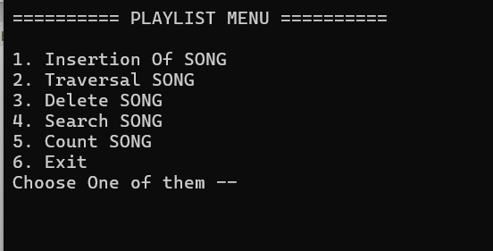

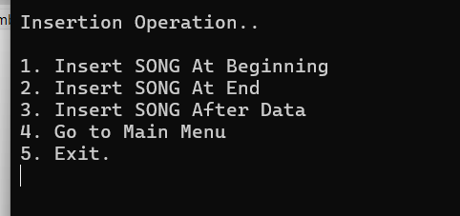

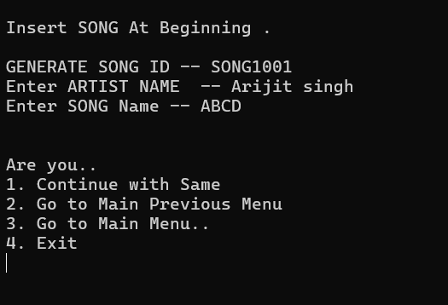

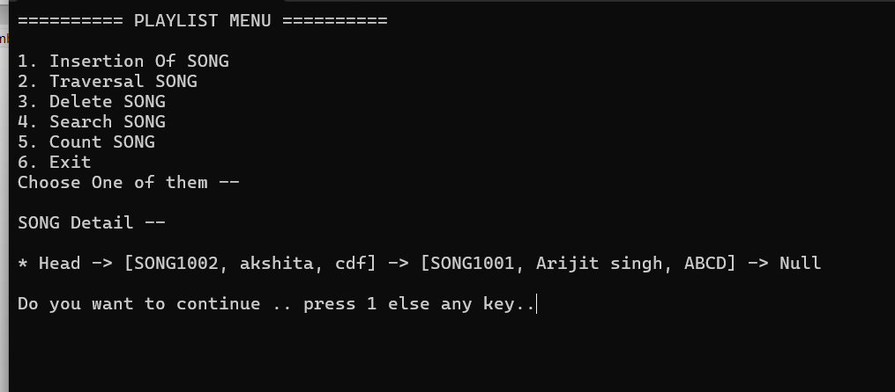

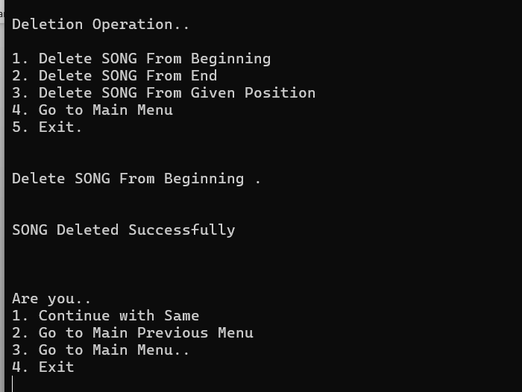

Dubbly LinkList
#include<iostream>
#include<conio.h>
#include<string>
using namespace std;
class NODED
{
public:
NODED *PREV;
string ID;
string ANAME;
string SONG;
NODED *NEXT;
NODED(string x, string y, string z)
{
PREV = nullptr;
ID = x;
ANAME = y;
SONG = z;
NEXT = nullptr;
}
};
class DLinkList
{
public:
string SID;
int SCNT;
string ANAME, USONG;
NODED *START,*END;
int countNode;
DLinkList(){
SCNT = 1001;
countNode = 0;
START = nullptr;
END = nullptr;
}
void getData()
{
SID = "SONG"+ to_string(SCNT);
cout<<"\nEnter SID -- "<<SID<<endl;
//getline(cin,SID);
cout<<"Enter ARTIST Name -- ";
//cin.ignore();
getline(cin,ANAME);
cout<<"Enter SONG -- ";
getline(cin,USONG);
}
char continueCheck()
{
char c;
cout<<"\n\nAre you.. \n";
cout<<"1. Continue with Same\n";
cout<<"2. Go to Main Previous Menu\n";
cout<<"3. Go to Main Menu..\n";
cout<<"4. Exit\n";
c = getch();
if ( c == '4'){
thanksLine();
exit(0);
}else{
return (c);
}
}
int insertNode(int opr)
{
system("cls");
if ( opr == 1){
cout<<"\n\nInsert SONG At Beginning . \n\n";
getData();
NODED *TEMP = new NODED(SID,ANAME, USONG);
if ( TEMP == nullptr){
cout<<"Insufficient Memory.. \n";
return 0;
}
if ( START == nullptr){
END = START = TEMP;
}
else{
TEMP->NEXT = START;
START->PREV = TEMP;
START = TEMP;
}
cout<<END->ANAME;
countNode++;
SCNT++;
}
else if ( opr == 2){
cout<<"\n\nInsert END At End . \n\n";
getData();
NODED *TEMP = new NODED(SID,ANAME, USONG);
if ( TEMP == nullptr){
cout<<"Insufficient Memory.. \n";
return 0;
}
if ( START == nullptr){
END = START = TEMP;
}
else{
END->NEXT = TEMP;
TEMP->PREV = END;
END = TEMP;
}
countNode++;
SCNT++;
}
else if ( opr == 3){
cout<<"\n\nInsert SONG At Given Position . \n\n";
cout<<"Total Nodes -- "<<countNode<<"\n\n";
int pos;
getData();
cout<<"Enter SONG Position Between 0 to "<<countNode<<" -- ";
cin>>pos;

NODED *TEMP = new NODED(SID,ANAME, USONG);
if ( TEMP == nullptr){
cout<<"Insufficient Memory.. \n";
return 0;
}
int i;
NODED *TEMP1 = START;
for ( i = 2 ; i < pos ; i++){
TEMP1 = TEMP1->NEXT;
}
if ( START == nullptr){
END = START = TEMP;
}
else{

TEMP->NEXT = TEMP1->NEXT;
TEMP1->NEXT = TEMP;
TEMP->PREV = TEMP1;
TEMP->NEXT->PREV=TEMP;
if ( TEMP1 == END){
END = TEMP1->NEXT;
}
}
countNode++;
SCNT++;
}
char c = continueCheck();
if (c == '1')
insertNode(opr);
else if ( c == '2')
insertionOperation();
else if ( c == '3')
MainMenu();
}
int showNode()
{
cout<<"\n\nDoubly Link List Traversal Of SONGS -- \n\n";
cout<<"* Head -> ";
if ( START == nullptr){
cout<<"null \n\nlist is empty\n";
return 0;
}
cout<<"\n\n1. Forward SONG Traversal..\n";
cout<<"2. Backward SONG Traversal\n";
cout<<"3. Goto to Main Menu..\n";
cout<<"4. Exit\n";
char c = getch();
if ( c == '1'){
cout<<"\n\nForward Traversal\n\n";
cout<<"null <- ";
NODED *TEMP = START;
while ( TEMP!= nullptr){
cout<<"["<<TEMP->ID<<", ";
cout<<TEMP->ANAME<<", ";
cout<<TEMP->SONG<<"] -> ";
TEMP = TEMP->NEXT;
}
cout<<"Null\n\n";
}
else if ( c == '2'){
cout<<"\n\nBackward SONG Traversal\n\n";
cout<<"null <- ";
NODED *TEMP = END;
while ( TEMP!= nullptr){
cout<<"["<<TEMP->ID<<", ";
cout<<TEMP->ANAME<<", ";
cout<<TEMP->SONG<<"] -> ";
TEMP = TEMP->PREV;
}
cout<<"Null\n\n";
}
else if ( c == '3'){
MainMenu();
}
else if (c == '4'){
exit(0);
}

}
void countNodes()
{
system("cls");
cout<<"Count SONG Nodes Module --\n\n";
cout<<"Total Number of SONG In nodes -- "<<countNode<<" SONG Nodes Available\n\n"
; }
int insertionOperation()
{
system("cls");
cout<<"\nInsertion Operation..\n\n";
cout<<"1. Insert SONG At Beginning\n";
cout<<"2. Insert SONG At End\n";
cout<<"3. Insert SONG After Data\n";
cout<<"4. Go to Main Menu\n";
cout<<"5. Exit.\n";
char c = getch();
if ( c == '1'){
insertNode(1);
}
else if ( c == '2'){
insertNode(2);
}
else if ( c == '3'){
insertNode(3);
}
else if ( c == '4'){
MainMenu();
}
else if ( c == '5'){
thanksLine();
exit(0);
}
}

int deleteNode(int opr)
{
NODED *TEMP;
if ( opr == 1){
cout<<"\n\nDelete SONG From Beginning . \n\n";
if ( START == nullptr)
{
cout<<"Playlist is Empty.. \n\n";
return 0;
}
else if ( START->NEXT == nullptr){
TEMP = START;
END = START = nullptr;
}
else{
TEMP = START;
START = START->NEXT;
START->PREV=nullptr;
}
countNode--;
delete(TEMP);
cout<<"\n SONG Node Deleted Successfully\n\n";
}
else if ( opr == 2){
cout<<"\n\nDelete SONG From End . \n\n";
if ( START == nullptr)
{
cout<<"Playlist is Empty.. \n\n";
return 0;
}
else if ( START->NEXT == nullptr){
TEMP = START;
END = START = nullptr;
}
else{
NODED *TEMP = END;
END = END->PREV;
END->NEXT = nullptr;
delete(TEMP);
}
countNode--;
cout<<"\n SONG Node Deleted Successfully\n\n";
}
else if ( opr == 3){
cout<<"\n\nDelete SONG From Given Position . \n\n";

if ( START == nullptr)
{
cout<<"Playlist is Empty.. \n\n";
return 0;
}
int pos;
cout<<"Enter Position for Delete (1 - "<<countNode<<") - ";
cin>>pos;
if ( pos == 1 && START == END)
{
TEMP = START;
START = END = nullptr;
}
else{
TEMP = START;
for (int i = 1 ; i < pos ; i++)
{
TEMP = TEMP->NEXT;
}
if (TEMP == END){
TEMP->PREV->NEXT = nullptr;
END = TEMP->PREV;
delete(TEMP);
}
else{
TEMP->PREV->NEXT = TEMP->NEXT;
TEMP->NEXT->PREV = TEMP->PREV;
delete(TEMP);
}
}
countNode--;
cout<<"\n SONG Node Deleted Successfully\n\n";
}
char c = continueCheck();
if (c == '1')
deleteNode(opr);
else if ( c == '2')
deleteOperation();
else if ( c == '3')
MainMenu();
}
int deleteOperation()
{
system("cls");
cout<<"\nDeletion Operation..\n\n";
cout<<"1. Delete SONG From Beginning\n";
cout<<"2. Delete SONG From End\n";
cout<<"3. Delete SONG From Given Position\n";
cout<<"4. Go to Main Menu\n";
cout<<"5. Exit.\n";
char c = getch();
if ( c == '1'){
deleteNode(1);
}
else if ( c == '2'){
deleteNode(2);
}
else if ( c == '3'){
deleteNode(3);
}
else if ( c == '4'){
MainMenu();
}
else if ( c == '5'){
thanksLine();
exit(0);
}
}
/*search module start*/

int searchSONGInNode()
{
cout<<"\n\nSearch SONG in Nodes -- \n\n";
cout<<"* Head -> ";
NODED *TEMP = START;
if ( START == nullptr){
cout<<"null \n\nlist is empty\n";
return 0;
}
else{
cout<<"\n\nEnter User Name To Find SONGS -- ";
string ANAME;
int counter = 0;
getline(cin,ANAME);
while ( TEMP!= nullptr){
if (TEMP->ANAME == ANAME)
{
cout<<"\n["<<TEMP->ID<<", ";
cout<<TEMP->ANAME<<", ";
cout<<TEMP->SONG<<"]\n";
counter++;
}
TEMP = TEMP->NEXT;
}
if ( counter == 0){
cout<<"\nNo SONG Found..\n\n";
}
}
char c;
cout<<"\n\nAre you .. \n";
cout<<"1. Continue with Same\n";
cout<<"2. Go to Main Menu..\n";
cout<<"3. Exit\n";
c = getch();
if (c == '1')
searchSONGInNode();
else if ( c == '2')
MainMenu();
else if ( c == '3'){
thanksLine();
exit(0);
}
}

/*Search Module End*/
int MainMenu()
{
system("cls");
cout<<"========== PLAYLIST MENU ==========\n\n";
cout<<"1. Insertion Operation\n";
cout<<"2. Traversal Operation\n";
cout<<"3. Delete Operation\n";
cout<<"4. Search Operation\n";
cout<<"5. Count Nodes\n";
cout<<"6. Exit\n";
cout<<"Choose One of them -- ";
/*l.insertNode(101,"Pooja","Hello Friends");
l.insertNode(102,"Niharika","Hello Pooja");
l.insertNode(103,"Deepak","Hello Tejswi");
l.showNode();*/
char c = getch();
if ( c == '1'){
insertionOperation();
}
else if ( c == '2'){
showNode();
}
else if ( c == '3'){
deleteOperation();
}
else if ( c == '4'){
searchSONGInNode();
}
else if ( c == '5'){
countNodes();
}
else if ( c == '6'){
thanksLine();
exit(0);
}
cout<<"\n\nDo you want to continue .. press 1 else any key..";
c = getch();
if ( c == '1'){
MainMenu();
}
}
void thanksLine()
{
cout<<"\n\nThanks for Using My APP\n\n";
}
};

/*int main()
{
DLinkList l;
l.MainMenu();
cout<<"\n\nThanks for Using My APP\n\n";
}*/

output

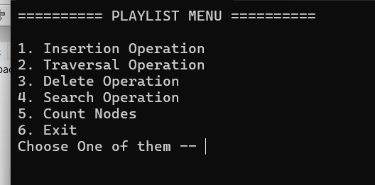

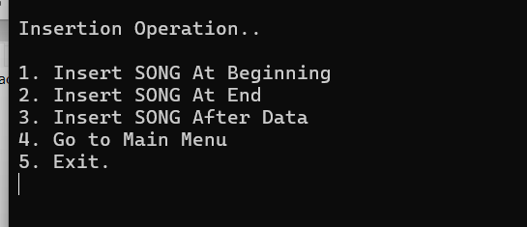

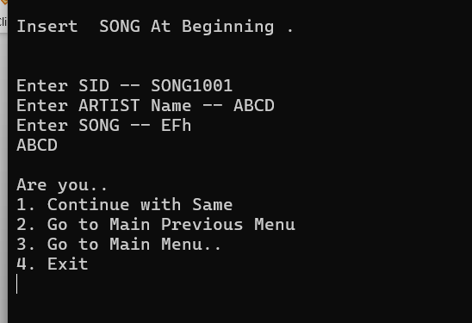

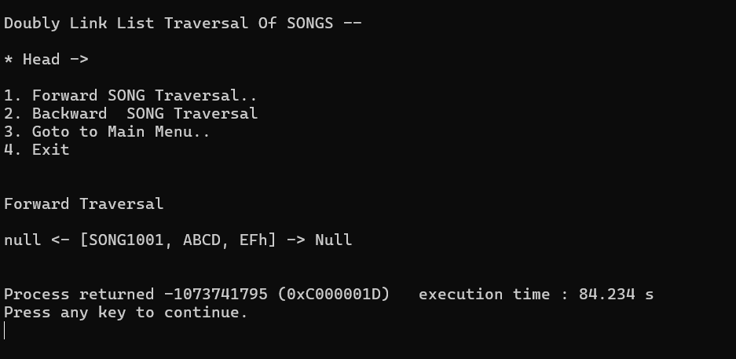

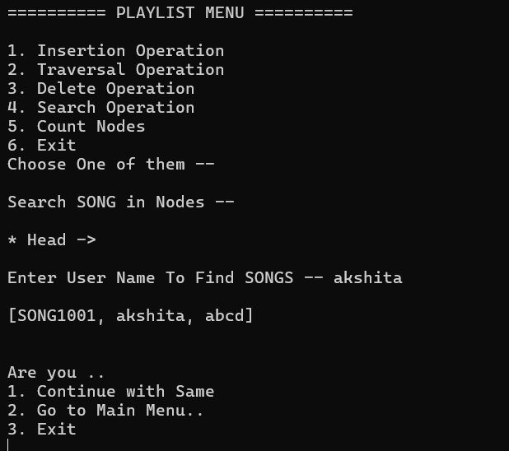

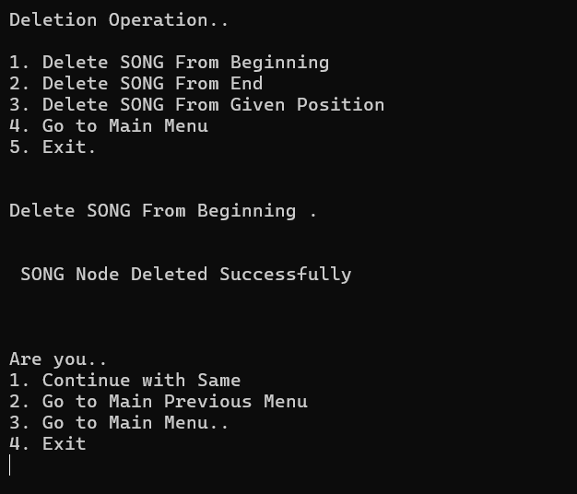

Scan & Check My Project on GitHub

THANKYOU

